**Group Number:** C1-027  
**Repository:** https://github.com/DP2-C1-027/AirNav-Logistics  
**Members:**

* **Garcia de Tejada Delgado, Jose**
  + Role: Developer
  + Email: josgardel8@alum.us.es
* **Peñaloza Friqui, Nora**
  + Role: Developer
  + Email: norpennfri@alum.us.es
* **Niza Cobo, Manuel Jesús**
  + Role: Manager, Developer
  + Email: mannizcob@alum.us.es
* **Gomez Claraco, Nicolas**
  + Role: Developer
  + Email: nicgomcla@alum.us.es
* **Campos Diez, Lucia**
  + Role: Tester, Developer
  + Email: [luccamdie@alum.us.es](mailto:luccamdie@alum.us.es)

**Date:** 19-02-2025

**Table of Contents**

1. Executive Summary
2. Revision Table
3. Introduction
4. Planning Chapter
   * Task Listing
   * Screenshots of Development Phases
   * Budget Estimation
5. Progress Chapter
   * Progress Records
   * Conflict Resolution
   * Cost Comparison
6. Conclusions
7. Bibliography

**Executive Summary**

This report details the planning and progress of our project deliverable, structured into two main sections: planning and progress. The planning chapter outlines task allocation, estimated efforts, screenshots of development phases, and budget estimations. The progress chapter provides performance records, conflict resolution approaches, and a cost comparison between the estimated and actual expenditures. This document ensures compliance with the project’s working methodology and best practices.

**Revision Table**

|  |  |  |
| --- | --- | --- |
| **Revision Number** | **Date** | **Description of Changes** |
| 1.0 | 10-02-2025 | Initial Draft |
| 1.1 | 14-02-2025 | Updated Cost Estimation |
| 1.2 | 20-02-2025 | Final Version |

**Introduction**

This document presents a structured report on the planning and progress of the project deliverable. It is divided into two main sections: the planning chapter, which includes task breakdown, screenshots from the project management tool, and budget estimation; and the progress chapter, which documents workgroup performance, conflict resolution, and a final cost comparison. The document follows a professional yet simple styling to ensure clarity and readability.

**Planning Chapter**

**Task Listing**

|  |  |  |  |  |  |
| --- | --- | --- | --- | --- | --- |
| Task | Description | Assignee | Role | Planned Time | Actual Time |
| Modify the anonymous menu | The anonymous menu was modified to display an option that redirects the browser to the homepage of a favorite website, with the title formatted as: “〈id-number〉: 〈surname〉, 〈name〉” | Nora Peñaloza | Developer | 30 minutes | 15 minutes |
| Provide a link to the GitHub planning dashboard | A link was provided to the planning dashboard for reviewing the task statuses and project schedule. | Nora Peñaloza | Developer | 30 minutes | 10 minutes |
| Planning and Progress Report | Created the planning and progress report with all the required details. | Nora Peñaloza | Developer | 3 hours | 5 hours |
| Analysis Report | Produced the analysis report with the corresponding logs. | Nora Peñaloza | Developer | 3 hours | 1 hours |
| Set up the workspace | Configured the workspace for the project. | Nora Peñaloza | Developer | 1.5 hours | 5 hours |
| Attend classes | Attended 6 classes (5 theory class and 1 follow-up), each lasting 1.5 hours | Nora Peñaloza | Developer | 9 hours | 9 hours |
| Recruiment Meeting | A post was made in the forum by the manager and i responded expressing my interest in joining the group. | Nora Peñaloza | Developer | 30 minutes | 5 minutes |
| Edit text files | Edited the changelog, contributors, license, and readme files of the repository to keep documentation up-to-date. | Nora Peñaloza | Developer | 2 hours | 1.5 hours |
| Report on WIS Testing | Created a report on the tests conducted on the WIS system. | Nora Peñaloza | Developer | 2 hours | 2 hours |
| Meeting1 | First meeting where we expressed our expectations regarding the work and the selection of the manager. | Nora Peñaloza | Developer | 1.5 hours | 1 hour |
| Meeting 2 | We share our progress and improvements for the first deliverable | Nora Peñaloza | Developer | 40 minutes | 1 hour |
| Modify the anonymous menu | The anonymous menu was modified to display an option that redirects the browser to the homepage of a favorite website, with the title formatted as: “〈id-number〉: 〈surname〉, 〈name〉” | Nicolás Gómez | Developer | 30 minutes | 20 minutes |
| Provide a link to the GitHub planning dashboard | A link was provided to the planning dashboard for reviewing the task statuses and project schedule. | Nicolás Gómez | Developer | 30 minutes | 5 minutes |
| Planning and Progress Report | Created the planning and progress report with all the required details. | Nicolás Gómez | Developer | 2 hours | 2 hours |
| Analysis Report | Produced the analysis report with the corresponding logs. | Nicolás Gómez | Developer | 3 hours | 2 hours |
| Change Banner Text, Banner, Logo, and Favicon | Update branding elements, including text, logo, and favicon. Simple UI change with minimal impact on code structure. | Nicolás Gómez | Developer | 2 hours | 1.5 hours |
| Customize the Fragments (Banner, Footer, Company, etc.) | Modify standard UI components to align with project branding. Required adjustments to UI component files with no major structural changes. | Nicolás Gómez | Developer | 2 hours | 4 hours |
| Modify the anonymous menu | The anonymous menu was modified to display an option that redirects the browser to the homepage of a favorite website, with the title formatted as: “〈id-number〉: 〈surname〉, 〈name〉” | Lucía Campos | Developer | 35 minutes | 20 minutes |
| Provide a link to the GitHub planning dashboard | A link was provided to the planning dashboard for reviewing the task statuses and project schedule. | Lucía Campos | Developer | 20 minutes | 5 minutes |
| Planning and Progress Report | Created the planning and progress report with all the required details. | Lucía Campos | Developer | 3 hours | 4 hours |
| Analysis Report | Produced the analysis report with the corresponding logs. | Lucía Campos | Developer | 3 hours | 2 hours |
| Set up the workspace | Configured the workspace for the project. | Lucía Campos | Developer | 1.5 hours | 5.5 hours |
| Attend classes | Attended 6 classes (5 theory class and 1 follow-up), each lasting 1.5 hours | Lucía Campos | Developer | 9 hours | 9 hours |
| Report on how you have set up your development configuration | Created a report on how you have set up your development configuration. | Lucía Campos | Developer | 2 hours | 2.5 hours |
| Planning and progress group report | Created the planning and progress group report with all the required details. | Lucía Campos | Developer | 3 hours | 4.5 hours |
| Meeting1 | First meeting where we expressed our expectations regarding the work and the selection of the manager. | Lucía Campos | Developer | 1.5 hours | 1 hour |
| Meeting 2 | We share our progress and improvements for the first deliverable | Lucía Campos | Developer | 40 minutes | 1 hour |

**Screenshots of Development Phases**

* **Initial Stage:**
* 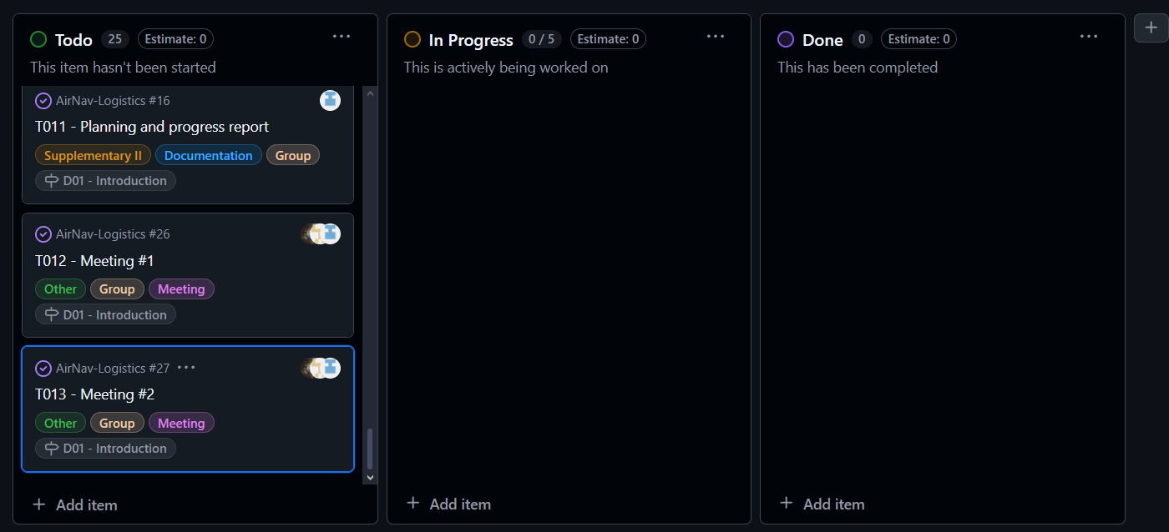
* **Midway Progress:** Captura de pantalla de un celular

  El contenido generado por IA puede ser incorrecto.**Completion:** Captura de pantalla de un celular

  El contenido generado por IA puede ser incorrecto.

**Budget Estimation**

**NORA**

|  |  |  |  |
| --- | --- | --- | --- |
| Role | Estimated Hours | Hourly Rate | Estimated Cost |
| Developer | 27 hours | €20/hr | €540 |
| Manager/Analyst | 0 hours | €30/hr | €0 |
| **Total Personnel Cost** | 27 **hours** | - | **€540** |
| Amortisation Cost | - | - | €20 |
| **Total Cost** | - | - | **€560** |

**NICOLÁS**

|  |  |  |  |
| --- | --- | --- | --- |
| Role | Estimated Hours | Hourly Rate | Estimated Cost |
| Developer | 9 hours | €20/hr | €180 |
| Manager/Analyst | 0 hours | €30/hr | €0 |
| **Total Personnel Cost** | **9 hours** | - | **€180** |
| Amortisation Cost | - | - | €[Calculated Value] |
| **Total Cost** | - | - | **€[Total Amount]** |

**LUCÍA**

|  |  |  |  |
| --- | --- | --- | --- |
| Role | Estimated Hours | Hourly Rate | Estimated Cost |
| Developer | 24.5 hours | €20/hr | €491.5 |
| Manager/Analyst | 0 hours | €30/hr | €0 |
| **Total Personnel Cost** | **24.5 hours** | - | **€491.5** |
| Amortisation Cost | - | - | €20.0 |
| **Total Cost** | - | - | **€511.5** |

**Progress Chapter**

**Progress Records**

|  |  |  |  |
| --- | --- | --- | --- |
| Member | Performance Indicator | Good/Bad | Action Taken |
| Nora Peñaloza | Completed tasks on time | Good | Recognition |
| Nicolás Gómez | Completed tasks on time | Good | Recognition |
| Manuel Jesús Niza | Completed tasks on time | Good | Recognition |
| **Jose Garcia de Tejada** | Completed tasks on time | Good | Recognition |
| **Lucía Campos** | Completed tasks on time | Good | Recognition |

**Conflict Resolution**

No conflicts arose during the period of work

**Cost Comparison**

|  |  |  |  |  |  |
| --- | --- | --- | --- | --- | --- |
| Role | Estimated Hours | Actual Hours | Hourly Rate | Estimated Cost | Actual Cost |
| Developer | 9 hours | 10 hours | €20/hr | €180 | €200 |
| Manager/Analyst | 0 hours | 0 hours | €30/hr | €0 | €0 |
| **Total Personnel Cost** | **9 hours** | **10 hours** | - | **€180** | **€200** |
| Amortisation Cost | - | - | - | €[Calculated Value] | €[Calculated Value] |
| **Total Cost** | - | - | - | **€[Total Estimated]** | **€[Total Actual]** |

🡪Nora:

|  |  |  |  |  |  |
| --- | --- | --- | --- | --- | --- |
| Role | Estimated Hours | Actual Hours | Hourly Rate | Estimated Cost | Actual Cost |
| Developer | 27 hours | 25.8 hours | €20/hr | €540 | €516 |
| Manager/Analyst | 0 hours | 0 hours | €30/hr | €0 | €0 |
| **Total Personnel Cost** | **27 hours** | **25.8 hours** | - | **€540** | **€516** |
| Amortisation Cost | - | - | - | €20 | €20 |
| **Total Cost** | - | - | - | **€560** | **€536** |

🡪Lucía:

|  |  |  |  |  |  |
| --- | --- | --- | --- | --- | --- |
| Role | Estimated Hours | Actual Hours | Hourly Rate | Estimated Cost | Actual Cost |
| Developer | 24.5 hours | 28 hours | €20/hr | €491.5 | €560 |
| Manager/Analyst | 0 hours | 0 hours | €30/hr | €0 | €0 |
| **Total Personnel Cost** | **24.5 hours** | **28 hours** | - | **€491.5** | **€560** |
| Amortisation Cost | - | - | - | €20 | €20 |
| **Total Cost** | - | - | - | **€511.5** | **€580** |

**Conclusions**

This report has documented the planning and execution of the project deliverable. The tasks were successfully completed with minor discrepancies in planned vs. actual time. Budget estimations were close to actual expenses, with minor deviations due to increased workload. Collaboration and adherence to the working methodology ensured the project’s success. Lessons learned include the importance of precise task estimations and proactive conflict resolution.

**Bibliography**

Intentionally blank.